**ASSIGNMENT 2 FRONT SHEET**

|  |  |  |  |
| --- | --- | --- | --- |
| **Qualification** | **BTEC Level 5 HND Diploma in Computing** | | |
| **Unit number and title** | Unit 19: Data Structures and Algorithms | | |
| **Submission date** | 1/9/2022 | **Date Received 1st submission** |  |
| **Re-submission Date** |  | **Date Received 2nd submission** |  |
| **Student Name** | Mai Thế Đức | **Student ID** | GCH200681 |
| **Class** | GCH0907 | **Assessor name** | Hong-Quan Do |
| **Student declaration**  I certify that the assignment submission is entirely my own work and I fully understand the consequences of plagiarism. I understand that making a false declaration is a form of malpractice. | | | |
|  |  | **Student’s signature** |  |

**Grading grid**

|  |  |  |  |  |  |  |  |
| --- | --- | --- | --- | --- | --- | --- | --- |
| P4 | P5 | P6 | P7 | M4 | M5 | D3 | D4 |
|  |  |  |  |  |  |  |  |

|  |  |  |
| --- | --- | --- |
| **❒ Summative Feedback: ❒ Resubmission Feedback:** | | |
| **Grade:** | **Assessor Signature:** | **Date:** |
| **Internal Verifier’s Comments:** | | |
| **IV Signature:** | | |

Table of Contents

Table of figures 4

Introduction 5

I. Implement complex data structures and algorithms 5

A. Singly vs. Doubly Linked-List 5

+) Doubly Linked-List 6

+) Singly linked-list 9

B. Insert an element in the middle of a Linked-List 13

C. Sorting in Linked-List 15

II. Testing plan 19

III. Asyptotic analysis 21

IV. Efficiency of an algorithm 23

References 24

# Table of figures

Figure 1: Big Oh Notation, Ο 21

Figure 2: Omega Notation, Ω 22

Figure 3: Theta Notation, θ 22

Figure 4: Recursive 23

Figure 5: Bubble sort 24

# Introduction

In keeping with the previous report, my role this time is to give appropriate implementations and evaluations for the corporate document. This article will discuss the distinctions between a singly linked list and a doubly linked list. I'll also give examples of how to implement key operations, such adding, deleting, and adding elements in the midst of a linked list. A sorting algorithm will be included in my linked list.

**P4: Implement a complex ADT and algorithm in an executable programming language to solve a well-defined problem.**

# I. Implement complex data structures and algorithms

## A. Singly vs. Doubly Linked-List

According to Sharma (2021), singly and doubly linked-list have some differences:

| Singly Linked List | Doubly Linked List |
| --- | --- |
| A Singly Linked has nodes with a data field and a next link field. | A Doubly Linked List has a previous link field along with a data field and a next link field. |
| The only way to traverse a singly linked list is by using the link to the node after it. | A Doubly Linked List allows for traversal utilising both the previous node link and the next node link. |
| Having only 2 fields, a singly linked list takes up less memory than a double linked list. | Due to its three fields, a doubly linked list takes up more memory than a singly linked list. |

### +) Doubly Linked-List

Doubly Linked-list look like this:

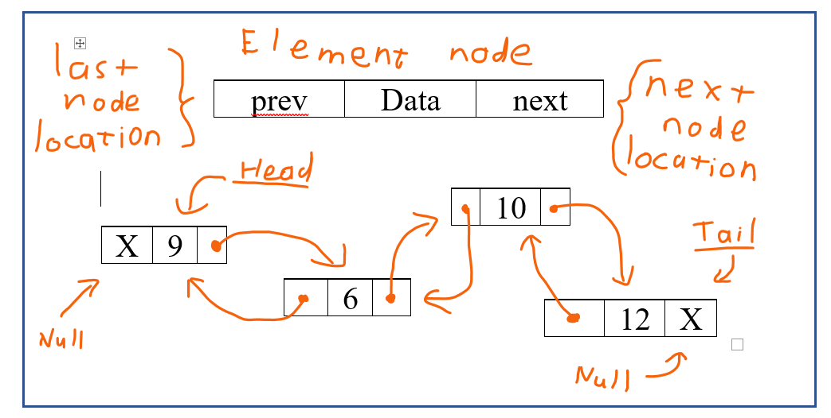

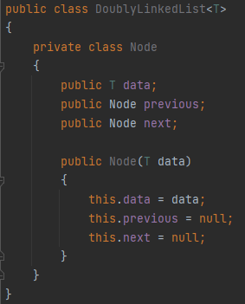

‘T’ is the type of element held in this collection

The data field contains the information or data, whereas the previous field contains the address of the node before it, and the next field contains the address of the node after it.

First step, we create a node class for doubly linked-list.



To begin, we set the head and tail to null.

+) Operation: add an element to the end of the list

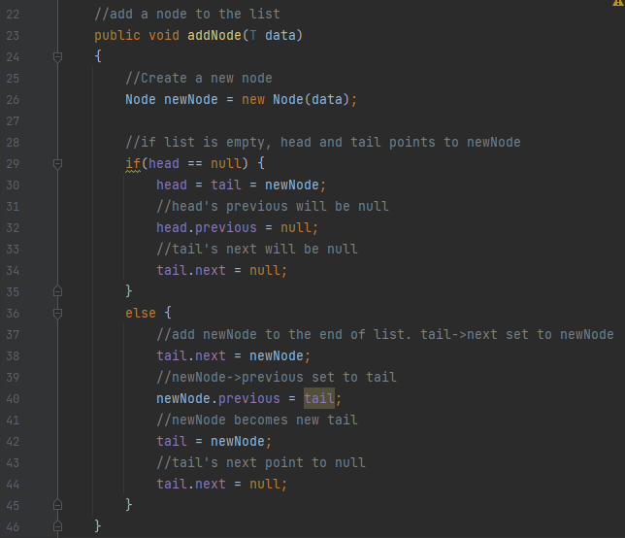

Line 26 we create a new Node. This new Node will be added to the linked-list.

From line 29 to 35, if the list is empty, we add in a new node and set the very first location of head is null, and also the very last location of tail is null. Now we have a linked-list with only 1 element.

From line 36 to 45, if there already some element in the linked-list then we add the new element in the last node of the linked-list. By making the new Node is the new tail, in line 38 the tail next location connects to the new node and in line 40 the new node previous location connects to the tail. In line 42, the new tail is now the new node. We also set the tail next location to be null.

+) Operation: remove the last element in the linked-list

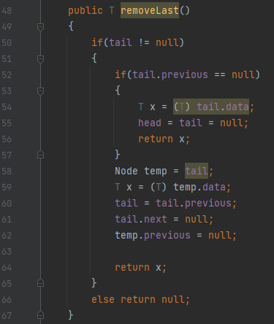

Line 50, if the linked-list is not empty then this function will work normally and remove element as usual. But if the linked-list is empty then in line 66 this operation will return null.

Line 52 to 57, this is the case when the linked-list have only 1 element. Therefore, ‘x’ is the element we remove, and we set the linked-list to be null. After remove the element, this operation return ‘x’ to help user know what element has been removed.

Line 58 to 64, if the linked-list have more than 1 element then this operation removes the last element from the list. ‘x’ is the element we remove. We set the almost last node to be tail then we cut the connection with the last node. But also line 62, we must clear the previous location of the last node to disconnect it entirely.

### +) Singly linked-list

Singly Linked-list look like this:

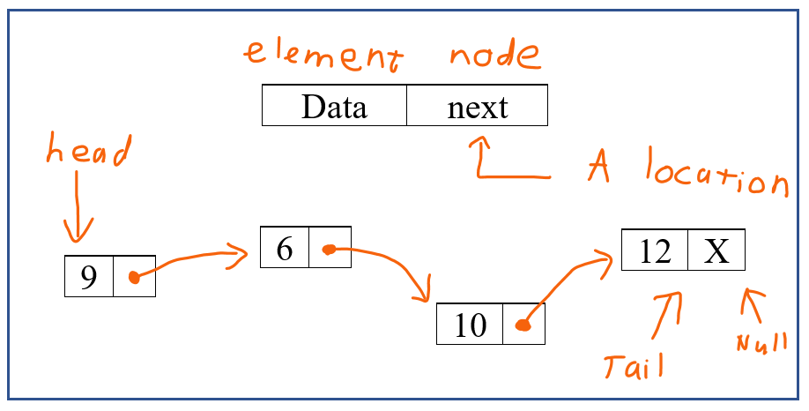

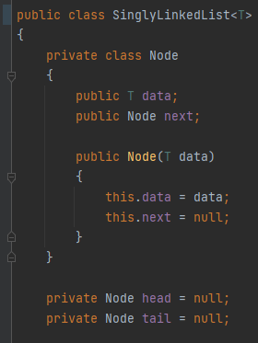

‘T’ is the type of element held in this collection

A Singly Linked has nodes with a data field and a next link field.

First step just like doubly list, we create node class for singly linked-list.

We also set the head and tail to be null.

+) Operation: add an element to the end of the list

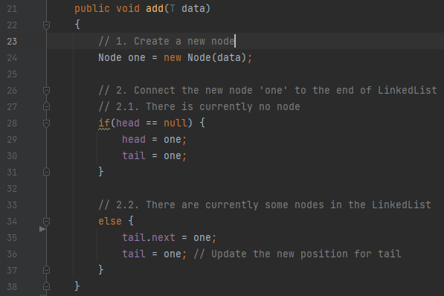

Line 24 we create a new Node. This new Node will be added to the linked-list.

From line 28 to 31, if the list is empty, we add in a new node. Now we have a linked-list with only 1 element.

From line 34 to 37, if there already some element in the linked-list then we add the new element in the last node of the linked-list. Line 35, we move the tail to the newest node. And then, in line 36 we update the tail new position to the node we added.

+) Operation: add an element to the first of the list

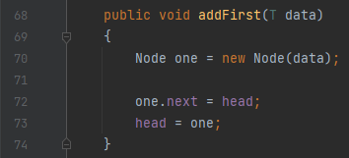

Difference with the operation add() from above. Operation addFirst() doesn’t care the linked-list have any element or not. It just easy add the new node to the first of the linked-list.

+) Operation: remove the first element in the linked-list

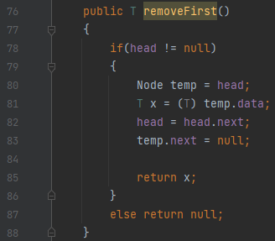

From line 78 to 86, if the list is not null then the operation removes the first element. Therefore, ‘x’ is the element we remove, and we set the linked-list to be null. After remove the element, this operation return ‘x’ to help user know what element has been removed.

Line 87, if the list have no element then this operation return null. +) Operation: remove the last element in the linked-list

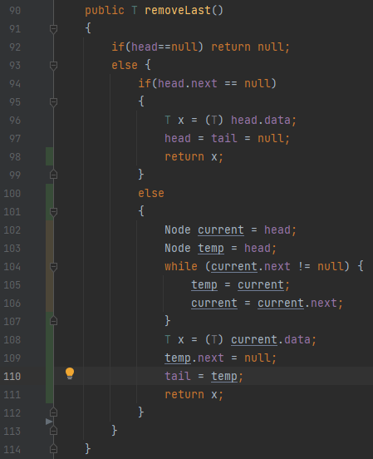

Line 92, if the linked-list is empty then this function will return null. Else, it runs from line 93 to 113.

Line 94 to 99, this is the case when the linked-list have only 1 element. Therefore, ‘x’ is the element we remove, and we set the linked-list to be null. After remove the element, this operation return ‘x’ to help user know what element has been removed.

Line 100 to 112, if the linked-list have more than 1 element then this operation removes the last element from the list. ‘x’ is the element we remove. We have ‘current’ and ‘temp’, node ‘current’ will go first then followed by node ‘temp’.

Line 104, until node ‘current’ stop at the last node in the list, the ‘temp’ will always behind ‘current’. So therefore in line 109 - 110, node ‘temp’ will be the new tail and then we cut the connection of it with node ‘current’.

Eventually line 111, we return ‘x’ to help the user know what element they have remove from the linked-list.

## B. Insert an element in the middle of a Linked-List

Continue from Singly linked-list.

+) Operation: add an element into the middle of the list

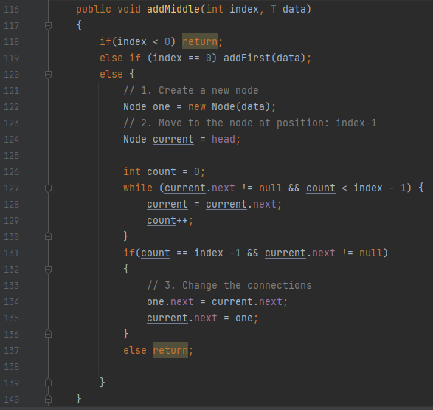

Line 116, we choose ‘index’ and the ‘data’ to add in the middle. So in line 118, if the ‘index’ is smaller than 0 then this operation will stop.

Line 119, if the ‘index’ equal 0 which mean the first element of the linked-list, we will use function addFirst() to operate the task. Line 120 to 139 are the case that ‘index’ > 1.

We use a node ‘current’ and start it at the head of the list. Then we use ‘count’ to locate the index that we want to add item. In line 127, if the ‘index’ we choose is bigger than the index of the list then the loop ‘while’ will stop. Line 137 will end the operation. Line 128 – 129, the node ‘current’ will follow ‘count’ one node behind.

But if ‘count’ found the index first then line 131 – 136 will execute adding the new node in that correct index. Line 134 – 135 will help node ‘one’ have the location of the next node, and also help the current node have the location of node ‘one’.

+) Operation: remove an element from the middle of the list

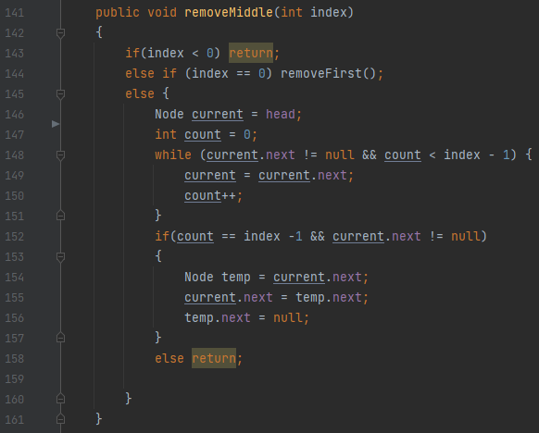

Similar to operation addMiddle(), line 143 – 144 in charge of checking the index user choose. If ‘index’ smaller than 0, the operation stops. If ‘index’ equal 0 which is remove the first and only element, the operation will use function removeFirst() above.

Line 145 – 160, if the ‘index’ is bigger than 0, the operation will continue. We use a node ‘current’ to track the node we want to remove. We also use ‘count’ again to find the right index.

Line 148 – 151, using a loop, the ‘count’ “move” forward and the ‘current’ step behind. If the ‘index’ user choose is bigger than the list, then operation stop. Until ‘count’ found the target index, Node ‘current’ still move right behind it.

Line 152 - 157, we use a node ‘temp’ as a target to remove. Now if ‘count’ found the match index, then node ‘current’ stand in index – 1 which mean right behind. Now node ‘temp’ is assign to the node where match the target index. The node ‘current’ will connect to the node where index + 1 which mean the next node of node ‘temp’. Lastly, in line 156, we disconnect the node ‘temp’ from the list and this operation has finished it job.

## C. Sorting in Linked-List

In this section, I use Merge Sort to sort the linked list. A sorting algorithm based on the Divide and Conquer paradigm is the Merge Sort algorithm. This algorithm divides the array into two equal parts, which are then combined in a sorted way.

How Merge Sort Work?

* Using recursive method to split the array in half until it cannot be further divided.

**P5 Implement error handling and report test results.**

# II. Testing plan

|  |  |  |  |  |  |  |  |
| --- | --- | --- | --- | --- | --- | --- | --- |
| **#** | **Scope** | **Operation** | **Testing type** | **Input** | **Expected Output** | **Actual Output** | **Status** |
| 1 | Doubly linked-list ADT:  Doubly  Linked  List  <Integer>  S2 | addNode(T data) | Normal | S2:[18,20,15];  addNode(24) | S2: [18,20,15,24]; | The same as expected output | Passed |
| 2 | removeLast() | Data  validation | S2:[];  removeLast() | S2: [];  Return null; | The same as expected output | Passed |
| Data  validation | S2:[18];  removeLast() | S2: [];  Return 18; | The same as expected output | Passed |
| Normal | S2:[18,20,15];  removeLast() | S2: [18,20];  Return 15; | The same as expected output | Passed |
| 3 | Singly linked-list ADT:  Singly  Linked  List  <Integer>  S1 | add(T data) | Normal | S1:[27,30,15];  add(24) | S1:[27,30,15,24]; | The same as expected output | Passed |
| 4 | addFirst(T data) | Normal | S1:[27,30,15];  addFirst(21) | S1:[21,27,30,15]; | The same as expected output | Passed |
| 5 | removeFirst() | Data  validation | S1:[];  removeFirst() | S1:[];  Return null; | The same as expected output | Passed |
|  | Normal | S1:[27,30,15];  removeFirst() | S1:[30,15];  Return 27; | The same as expected output | Passed |
| 6 | removeLast() | Data  validation | S1:[];  removeLast() | S1:[];  Return null; | The same as expected output | Passed |
| Data  validation | S1:[27];  removeLast() | S1:[];  Return 27; | The same as expected output | Passed |
| Normal | S1:[27,30,15];  removeLast() | S1:[27,30];  Return 15; | The same as expected output | Passed |
| 7 | addMiddle(int index, T data) | Data  validation | S1:[27,30,15];  addMiddle(-1,11) | S1:[27,30,15]; | The same as expected output | Passed |
| Data  validation | S1:[27,30,15];  addMiddle(0,11) | S1:[11,27,30,15]; | The same as expected output | Passed |
| Normal | S1:[27,30,15];  addMiddle(1,11) | S1:[27,11,30,15]; | The same as expected output | Passed |
| Data  validation | S1:[27,30,15];  addMiddle(3,11) | S1:[27,30,15]; | The same as expected output | Passed |
| 8 | removeMiddle  (int index) | Data  validation | S1:[27,30,15];  removeMiddle(-1) | S1:[27,30,15]; | The same as expected output | Passed |
| Data  validation | S1:[27,30,15];  removeMiddle(0) | S1:[30,15]; | The same as expected output | Passed |
| Normal | S1:[27,30,15];  removeMiddle(1) | S1:[27,15]; | The same as expected output | Passed |
| Data  validation | S1:[27,30,15];  removeMiddle(3) | S1:[27,30,15]; | The same as expected output | Passed |
| 9 | Sort(Singly  Linked  List  <Integer>  List) | Normal | S1:[27,30,15,24];  Sort(S1) | S1:[15,24,27,30]; | The same as expected output | Passed |
| Data  validation | S1:[];  Sort(S1) | S1:[];  Print an error message | S1:[];  The system is stopped! | Failed |

The sort operation can be improve by manage to return null if there are no element in the linked-list.

**P6 Discuss how asymptotic analysis can be used to assess the effectiveness of an algorithm**

# III. Asyptotic analysis

Calculating the execution time of any operation in terms of mathematical computation units is known as asymptotic analysis. An algorithm's asymptotic analysis involves determining the mathematical bounds or frames of its run-time performance. We may easily draw conclusions about an algorithm's best case, average case, and worst case scenarios using asymptotic analysis (tutorialspoint, 2022).

According to tutorialspoint (2022), there are 3 commonly used asymptotic notations:

* Ο Notation
* Ω Notation
* θ Notation

+) Big Oh Notation: Ο

The formal notation for expressing the upper bound of an algorithm's execution time is O(n). It calculates the worst-case time complexity, or the maximum time an algorithm can take to run (tutorialspoint, 2022).

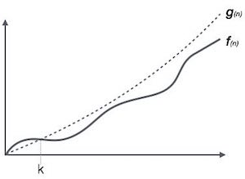

Figure : Big Oh Notation, Ο

Example:

Selection sort have O(n2). Quick sort have O(n*log n). Binary search have O(log n). Simple search have O(n).

+) Omega Notation: Ω

The formal notation for expressing the lower bound of the execution time of an algorithm is (n). It gauges the lowest possible level of time complexity or the fastest possible time an algorithm may run (tutorialspoint, 2022).

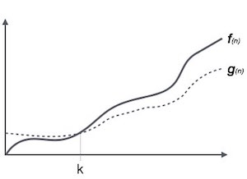

Figure : Omega Notation, Ω

Example:

Bubble sort have O(n), Heap sort have O(n*log n).

+) Theta Notation: θ

The formal notation for expressing the lower and upper bounds of an algorithm's execution time is (n). Also, we consider it average run time (tutorialspoint, 2022).

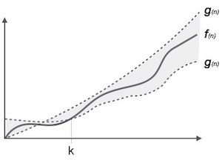

Figure : Theta Notation, θ

Example:

Tree sort have O(n*log n), Radix sort have O(nk).

**P7 Determine two ways in which the efficiency of an algorithm can be measured, illustrating your answer with an example.**

# IV. Efficiency of an algorithm

To ascertain an algorithm's resource utilisation, an analysis of the algorithm is required. The quantity of computer resources that an algorithm uses is referred to as the algorithm's efficiency. As a result, the effectiveness of an algorithm can be evaluated depending on how various resources are used. We want to use as little resources as possible for an algorithm to run as efficiently as possible (Kumari, 2022).

There are 2 type of algorithm’s complexity:

* Space complexity
* Time complexity

+) Time complexity

The amount of memory needed for a programme to run is referred to as the function input when describing the space complexity of an algorithm.

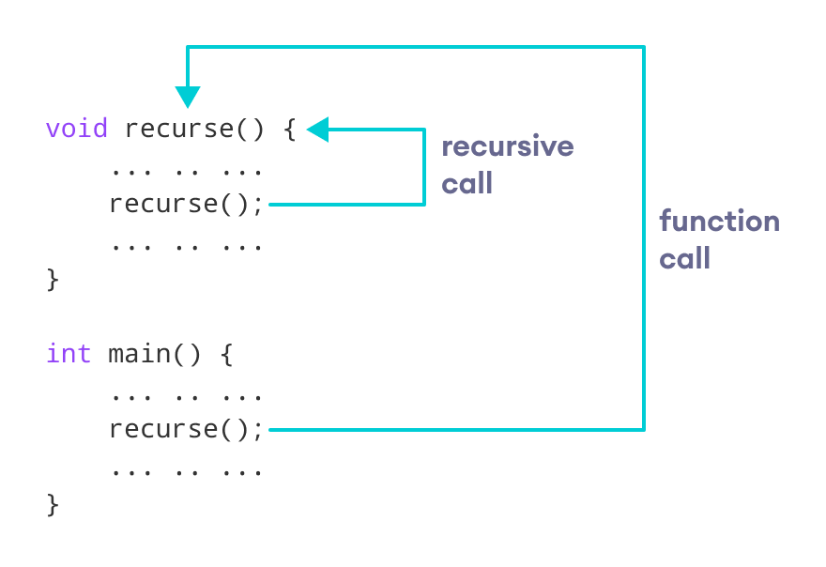

Figure : Recursive

For example, recursive method help save space of memory. If I want to sum: 100 + 99 + … + 1, is not hard but if the sum is n + (n-1) + … + 1 will be space consume. But with recursive we can call it again and again to save space.

Another easy example is try to make all operation work with each other with the same data set.

+) Time complexity

Time complexity is the amount of time required to execute an algorithm completely. The same variables that affect space difficulty also affect time complexity.

The best example is choosing the best case algorithm for the scenario. For example, Bubble sort have the best case O(n). So if you sort an array which not large, then Bubble sort will be very fast compare to other sorting algorithm.

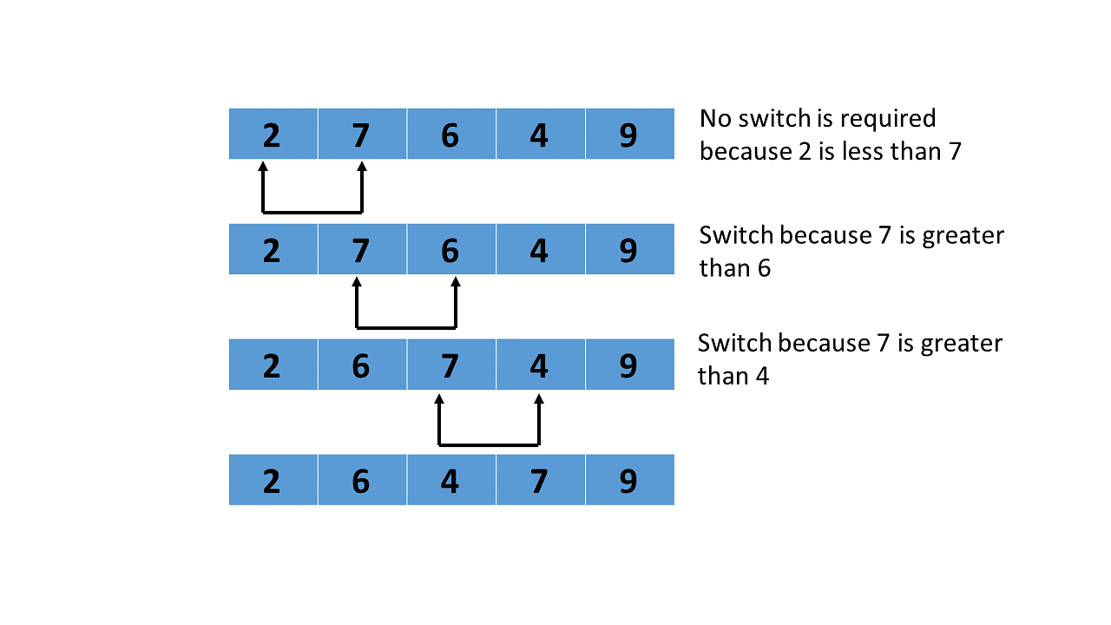

Figure : Bubble sort

# References

Kumari, M., 2022. *Efficiency of an Algorithm: Time Complexity & Space Complexity.* [Online]   
Available at: https://byjusexamprep.com/efficiency-of-an-algorithm-i  
[Accessed 1 September 2022].

Sharma, A., 2021. *Difference between a Singly Linked List and a Doubly Linked List.* [Online]   
[Accessed 1st August 2022].

tutorialspoint, 2022. *Data Structures - Asymptotic Analysis.* [Online]   
[Accessed 1 September 2022].